  University of Buea | Faculty Of Engineering & Technology
Computer Department | Software Engineering

CEF440 – Internet and Mobile Programming (Task 2)

Task 3: Design and Implementation of a Mobile App for Collection of User Experience Data from Mobile Network Subscribers

Group List
Name | Matricule
Mugha Brayan Aya-ah Ndefru | FE23A097
Ako McPeace Njoh | FE23A009
EYONG AKAGO ANELKA NELVINE | FE23A056
NGOLIEN LUCY ETHEL LIBOG | FE22A261

Github Repository: https://github.com/BrayanMorningstar237/CEF440_Group5

Table of Contents
REQUIREMENTS GATHERING AND ANALYSIS REPORT 3
Introduction 3
Methodology 3
Data Collection Workflow 3
Analysis of User Technical Environment 4
Distribution of Mobile Operating Systems 5
Dual-SIM Usage Distribution 6
Analysis of Network Experience 7
Most Common Network Issues Reported 7
User Interaction and Feedback Preferences 9
Preferred Feedback Frequency 9
Preferred Feedback Method 10
Privacy and Trust Analysis 11
User Privacy Concerns 11
System Constraints and Operational Considerations 12
User Sensitivity to Battery and Data Usage 13
User Motivation and Adoption Factors 14
Factors Influencing User Adoption 15
Language and Localisation 16
Analysis of Programming Languages and Technology Options 17
Implications for System Design and Technology Selection 18
Conclusion 18
REFERENCES 20

REQUIREMENTS GATHERING AND ANALYSIS REPORT

Introduction
The development of a mobile application for collecting Quality of Experience (QoE) data from mobile network subscribers requires a thorough understanding of user behavior, technical constraints, and environmental conditions. In developing regions such as Cameroon, mobile users frequently encounter inconsistent network performance, including slow data speeds, unstable connectivity, and service interruptions. Despite existing Quality of Service monitoring mechanisms employed by network operators, there remains a gap in capturing real user experiences, which are essential for improving service delivery.
This report presents the findings from a structured requirements gathering and analysis process conducted among mobile network subscribers. The objective is to identify key technical, behavioral, and contextual factors that influence the design, usability, and adoption of the proposed system. The results serve as a foundation for defining system requirements and guiding technology selection for implementation.

Methodology
The requirements elicitation process was conducted using a structured questionnaire targeting mobile subscribers. The questionnaire was designed to capture both technical and experiential data, including device characteristics, network usage patterns, user interaction preferences, privacy concerns, and willingness to adopt a background monitoring application.
A total of fifty + responses were collected and analyzed using descriptive methods. The results were interpreted to identify patterns and trends relevant to system design and feasibility.

Data Collection Workflow

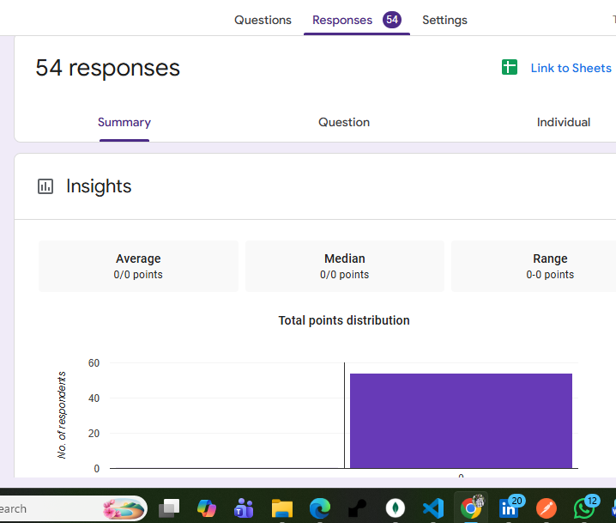

Analysis of User Technical Environment
The analysis shows that the majority of respondents use Android-based smartphones, confirming Android as the primary platform for the proposed system. A portion of users operate on older or unspecified versions, highlighting the need for compatibility across a range of Android API levels.
The analysis indicates that 75.9% of respondents use Android-based smartphones, confirming Android as the dominant platform for the proposed system. Additionally, 50% of Android users are on Android 13 or higher, while a notable portion use older or unspecified versions. This distribution underscores the importance of ensuring compatibility across a wide range of Android API levels to accommodate device fragmentation.
However, despite Android’s clear majority, a significant minority of users operate on iOS devices. This is non-negligible from a system design perspective. Therefore, the proposed solution should not be exclusively Android-centric; instead, it should adopt a cross-platform strategy or include provisions for iOS support to ensure broader accessibility, inclusivity, and user adoption.

Distribution of Mobile Operating Systems
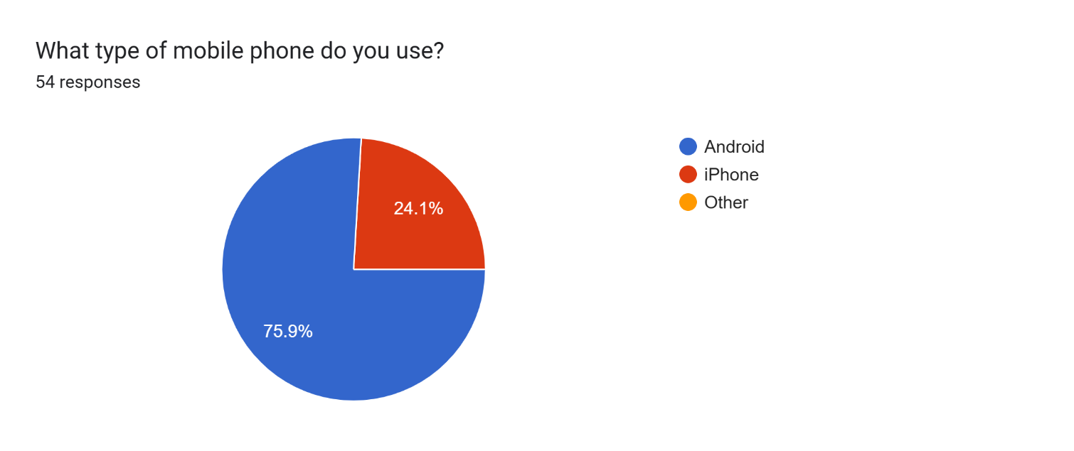
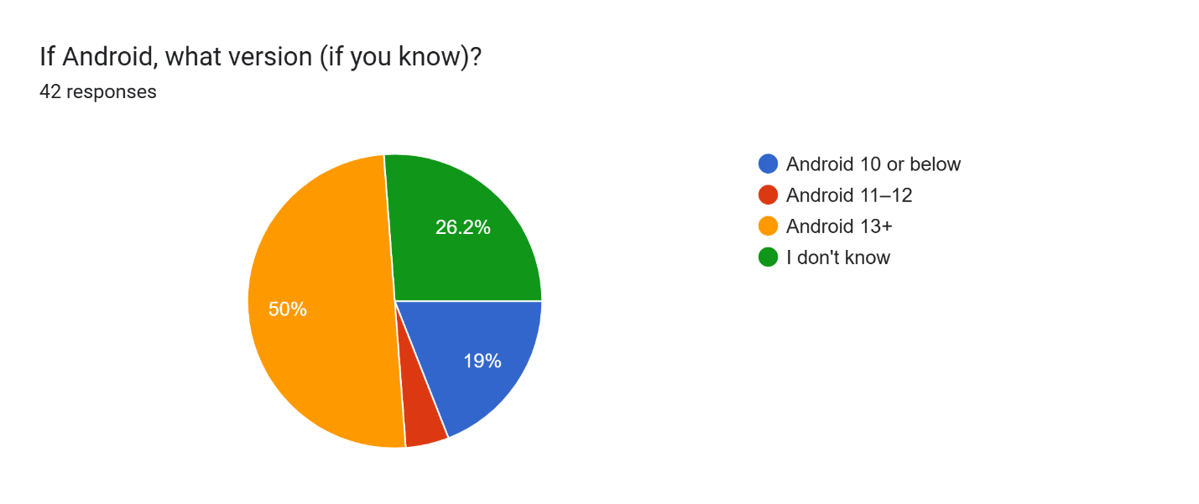
Additionally, a significant number of users reported using dual-SIM devices, often switching between network providers based on availability and cost.

Dual-SIM Usage Distribution
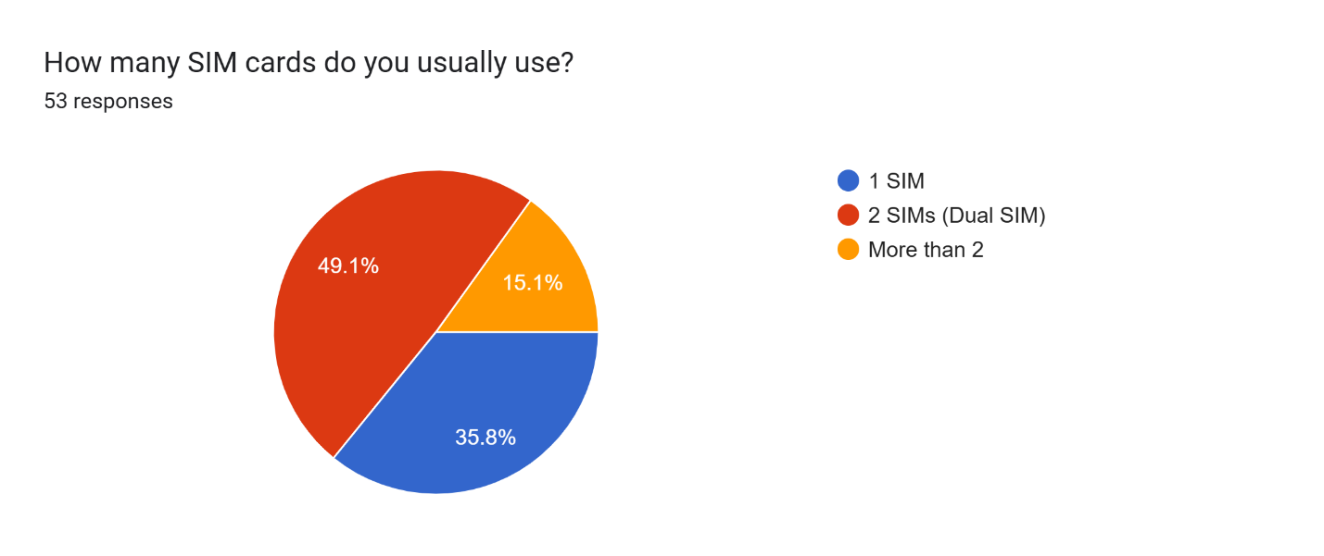
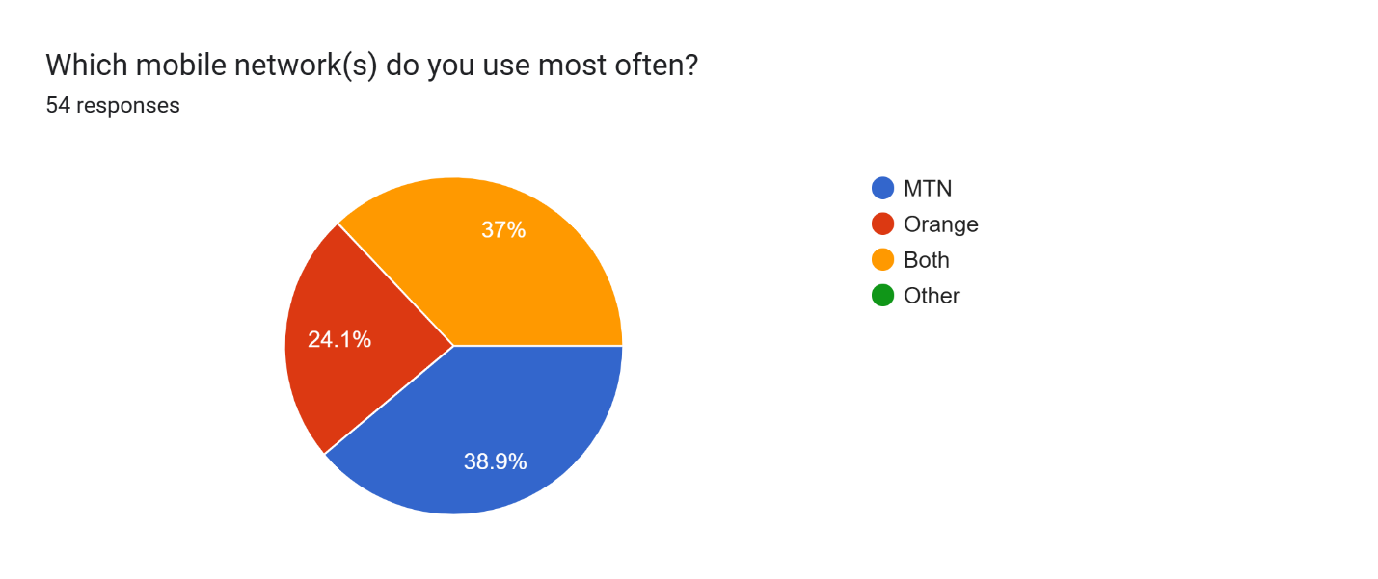
This behavior introduces a critical requirement for detecting the active data SIM to ensure that collected network metrics are accurately associated with the correct operator.

Analysis of Network Experience
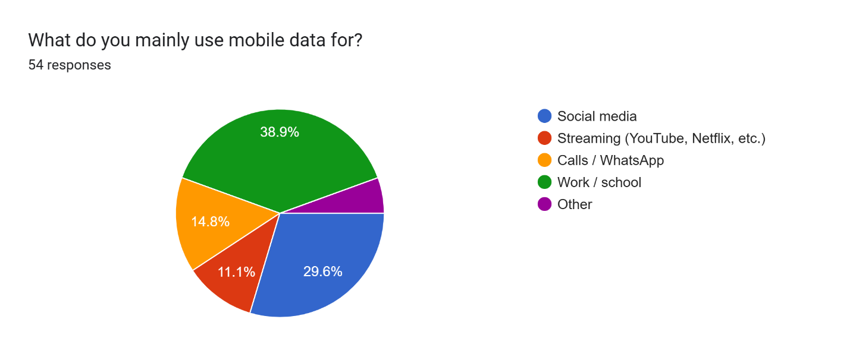
The responses indicate that users frequently experience poor network conditions, including slow internet speeds, weak signal strength, and intermittent connectivity. These issues occur across different locations and times, suggesting persistent network performance challenges.

Most Common Network Issues Reported
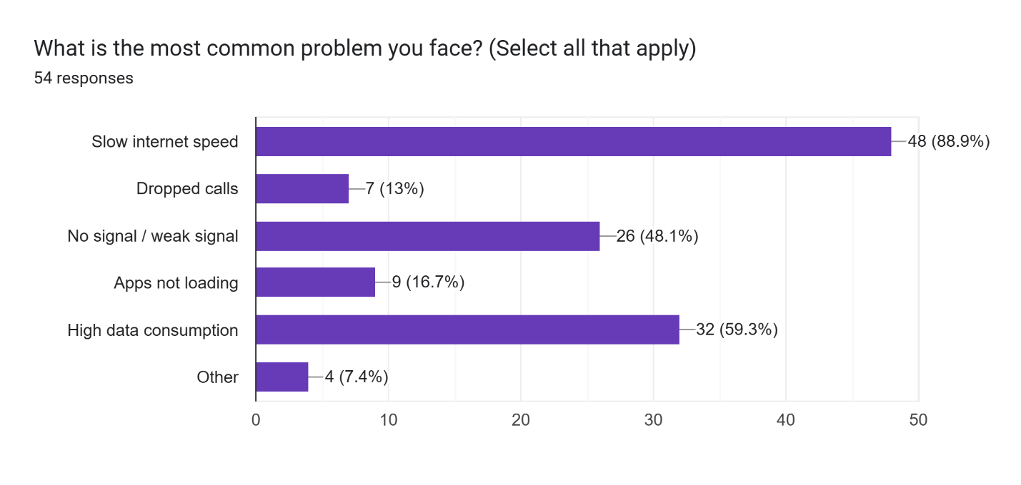
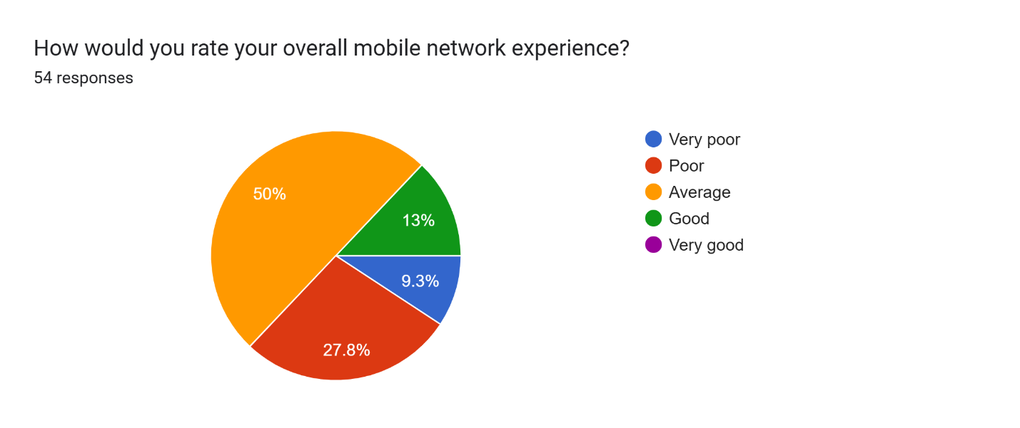
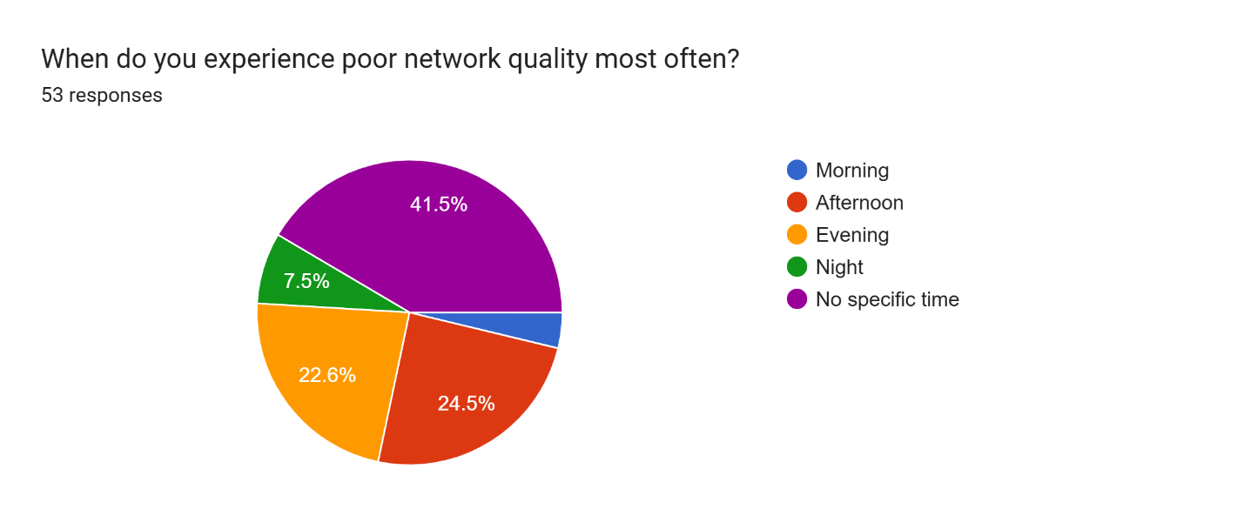
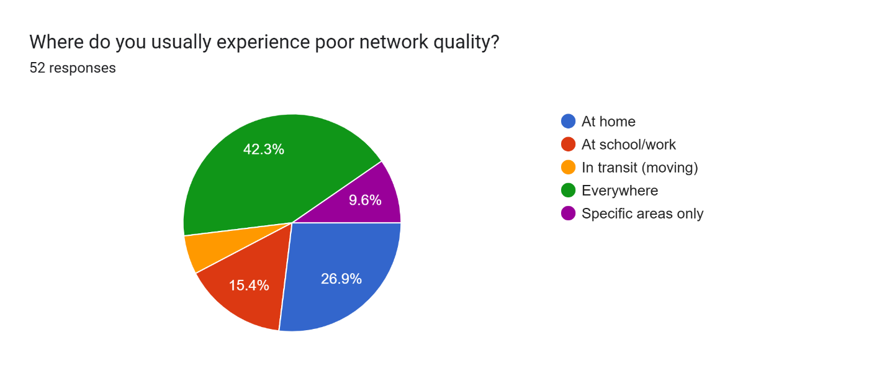
These findings justify the need for continuous monitoring of network performance metrics such as latency, jitter, packet loss, and signal strength. They also reinforce the importance of collecting subjective user feedback to complement objective measurements, thereby providing a complete view of network performance.

User Interaction and Feedback Preferences
Users expressed a preference for minimal and non-intrusive interaction with the application. Most respondents indicated that they are willing to provide feedback only occasionally, particularly when prompted after experiencing a network issue.

Preferred Feedback Frequency
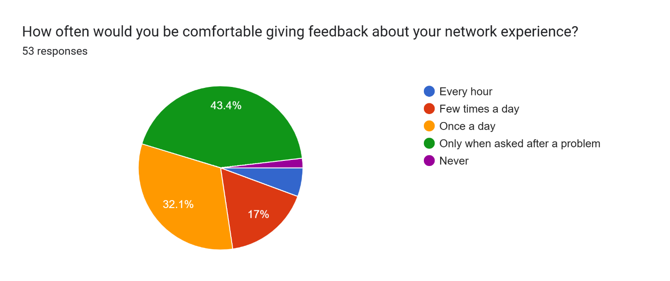

Simple interaction methods such as rating scales or emoji-based feedback were preferred, with most users indicating that they are willing to spend less than ten seconds providing feedback.

Preferred Feedback Method
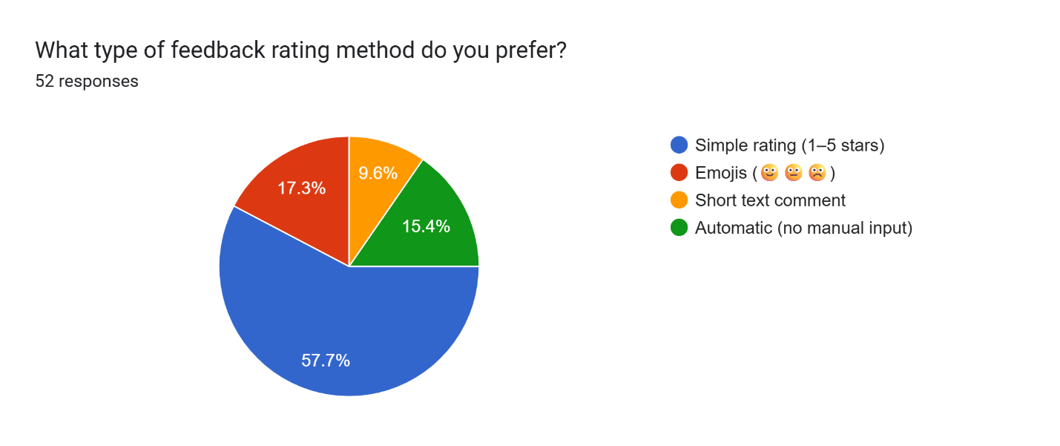
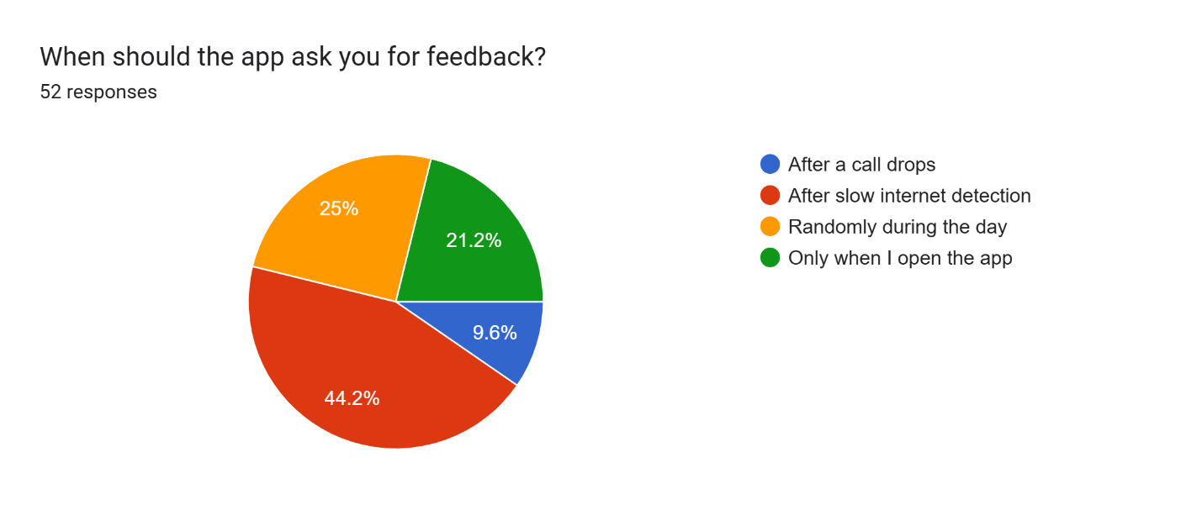
These findings establish key usability requirements, including the need for fast, intuitive, and context-aware feedback mechanisms. The system must avoid frequent interruptions and instead rely on intelligent triggering strategies.
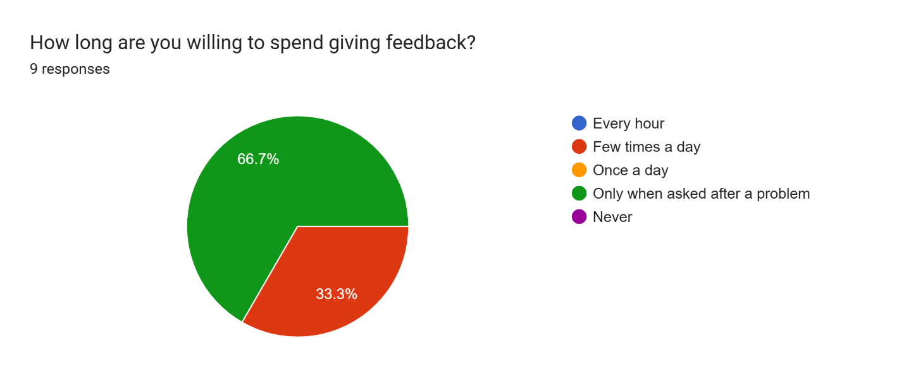

Privacy and Trust Analysis
Privacy concerns were identified as a major factor influencing user acceptance. While some users are willing to allow background data collection, this is conditional on transparency, control, and assurance that personal data is not being accessed.

User Privacy Concerns
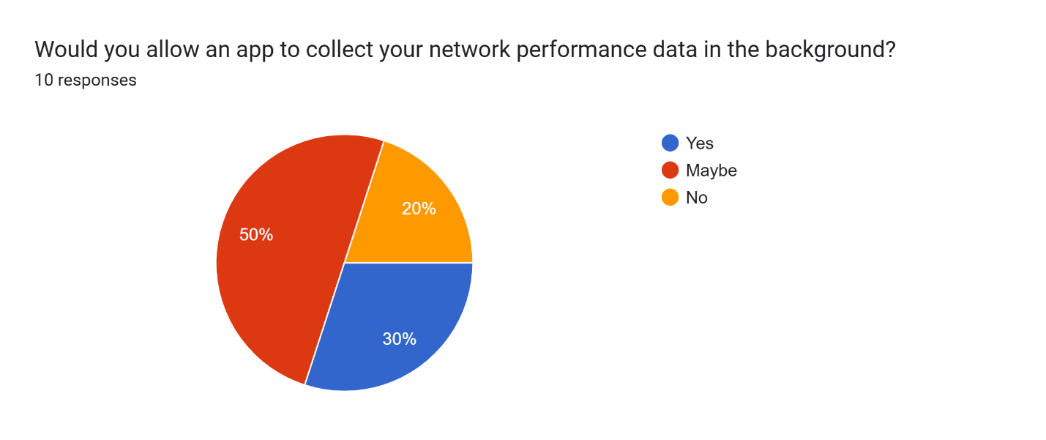
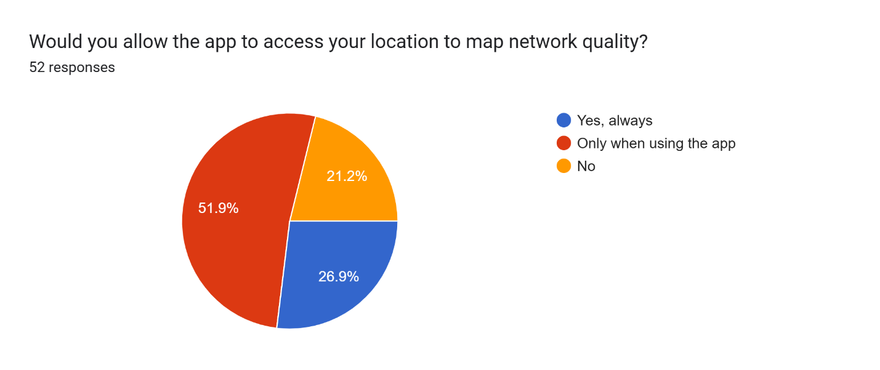
Users expressed particular concern about location tracking and background activity. To address these concerns, the system must implement strict privacy measures, including anonymization of data, minimal data collection, and clear communication of data usage.
The application must explicitly state that it does not access personal information such as messages or calls and must provide users with control over permissions.

System Constraints and Operational Considerations
The analysis highlights several practical constraints, including limited battery capacity, low-end device capabilities, and unstable network connectivity.

User Sensitivity to Battery and Data Usage
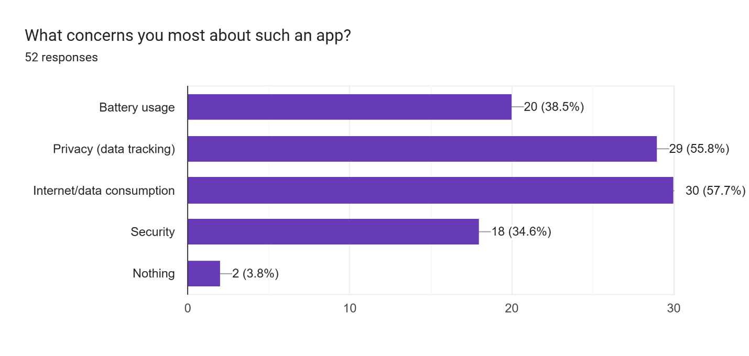
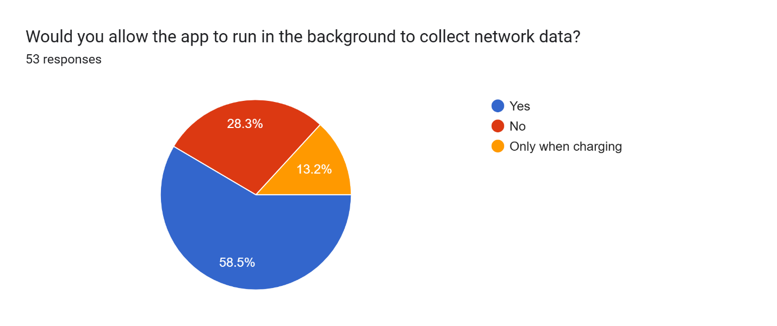
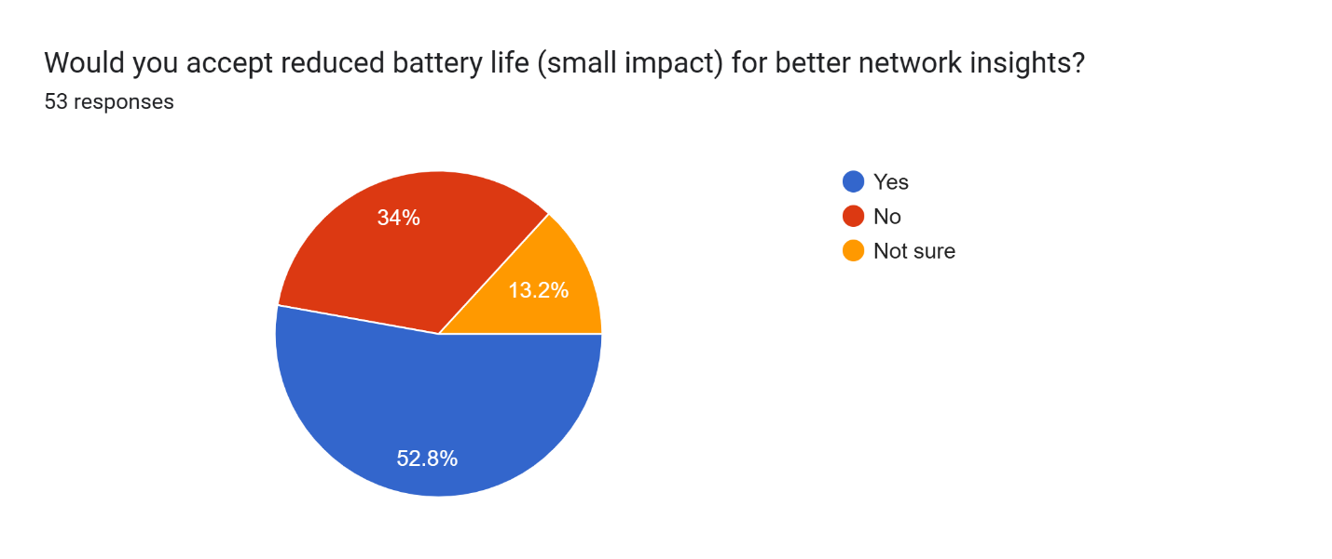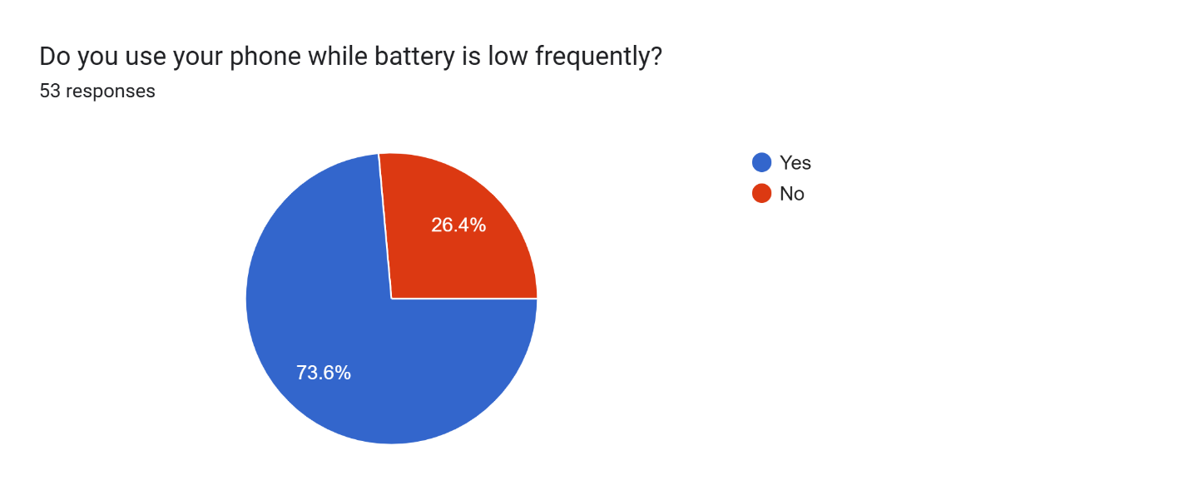
These constraints require the system to adopt an energy-efficient design, minimizing background activity and using adaptive data collection strategies. The application must also support offline data storage and delayed synchronization to accommodate intermittent connectivity.
These requirements influence the use of lightweight local storage mechanisms and efficient background processing frameworks.

User Motivation and Adoption Factors
The long-term success of the application depends on user retention. The analysis shows that users are more likely to keep the application installed if it provides tangible benefits, such as insights into their own network performance or contributions to improving network quality.
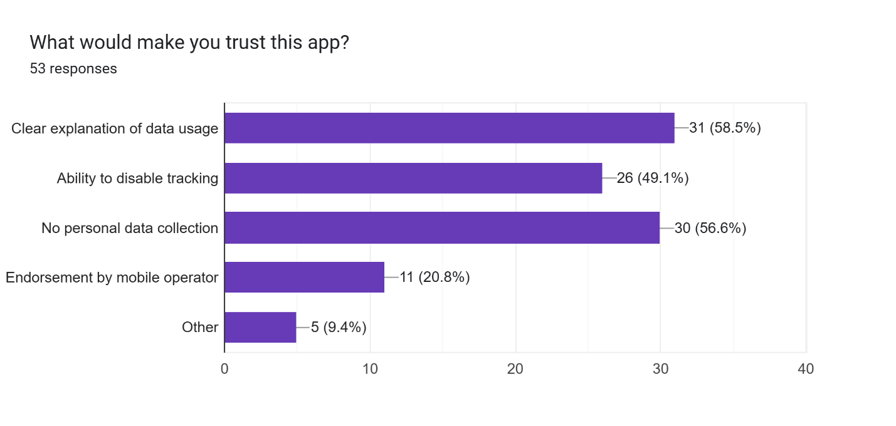

Factors Influencing User Adoption
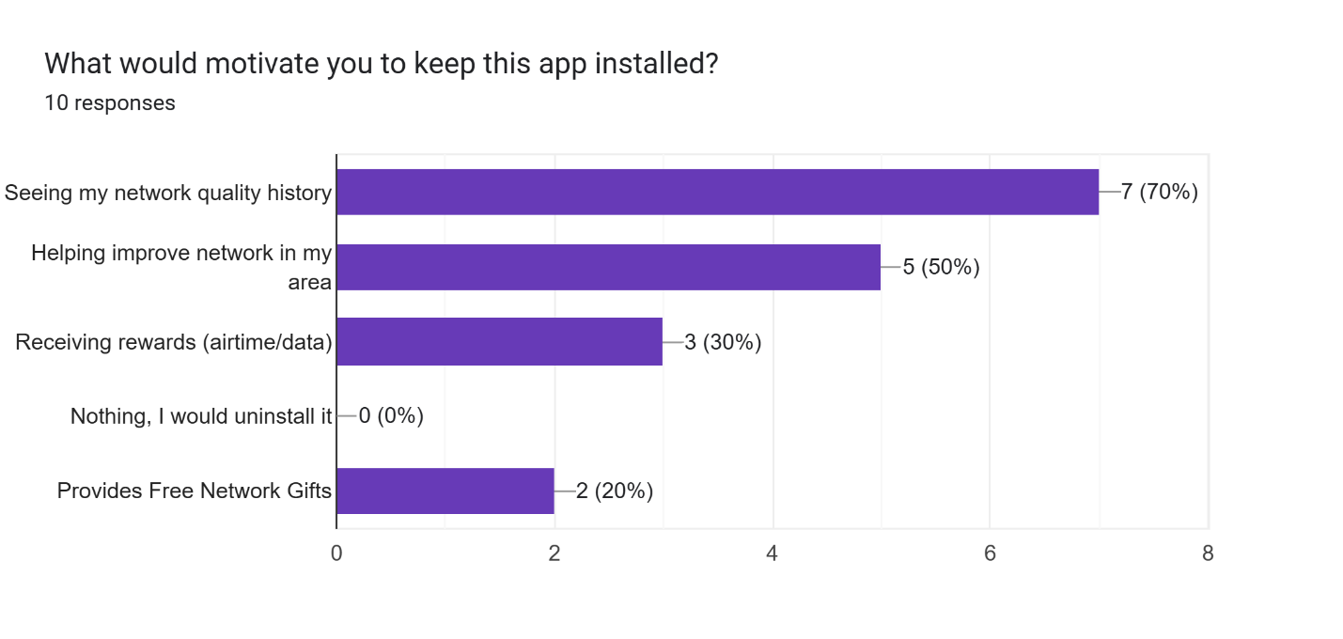
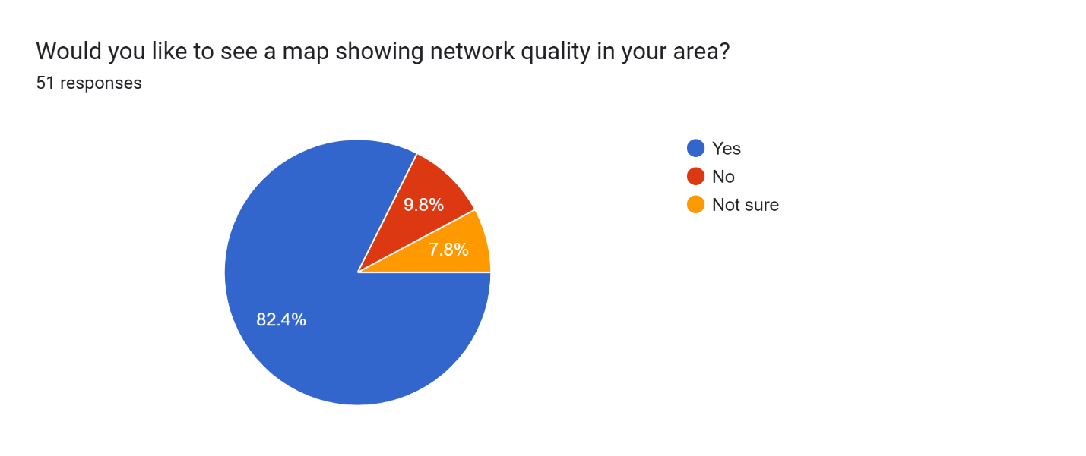
This suggests that the system should include user-facing features such as performance summaries or simple dashboards to enhance engagement and perceived value.

Language and Localisation
The survey results on language preference show that 49.1% of respondents prefer English, while 43.4% prefer a bilingual option (English and French). A smaller proportion of users indicated a preference for French only.
This distribution highlights that English is the primary language, but there is a strong demand for bilingual support. Therefore, the application should adopt English as the default interface language, with an option for users to switch to French as needed.
Implementing a language toggle or localization feature will ensure accessibility for both Anglophone and Francophone users, which is particularly important in the Central African context where both languages are widely used.

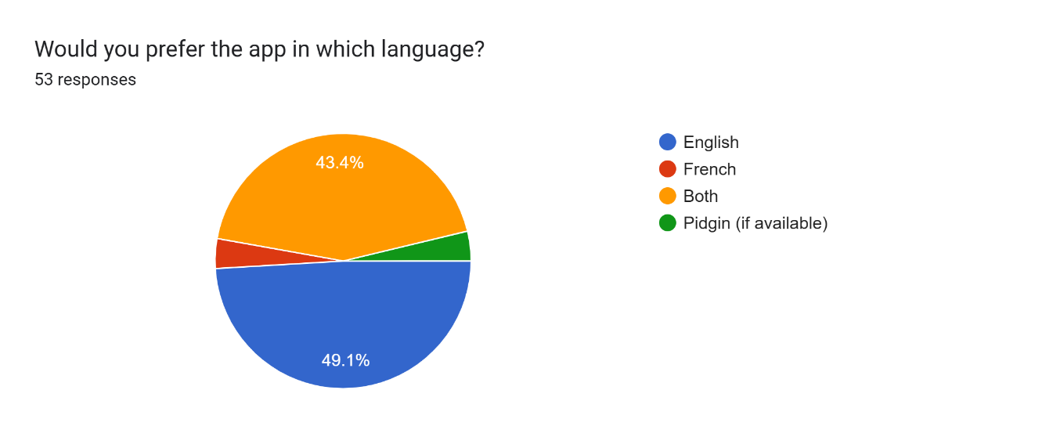

Analysis of Programming Languages and Technology Options
In addition to mobile development considerations, it is important to evaluate backend and network-processing technologies suitable for handling collected data and supporting system scalability.
Python is widely recognized for rapid development and ease of implementation. Its extensive ecosystem supports network measurement, data processing, and visualization. Libraries for handling network operations and analyzing data make Python particularly suitable for prototyping and analytics.
Go (Golang), on the other hand, is optimized for high-performance and concurrent systems. Its lightweight concurrency model allows efficient handling of multiple network operations, making it suitable for large-scale data processing and real-time systems.
While lower-level languages such as C and C++ offer high precision, they introduce complexity and longer development time. Rust provides performance and safety but requires a steeper learning curve.
A critical architectural consideration is that network measurements such as upload and download speeds must be performed on the mobile device to reflect the user’s actual network conditions. Backend systems should focus on data aggregation, processing, and storage rather than direct measurement.

Implications for System Design and Technology Selection
Based on the requirements analysis, the system will adopt a client-server architecture. The mobile application will be developed natively for Android using Kotlin, ensuring efficient interaction with device-level APIs and optimized background processing.
The application will use WorkManager for scheduling background tasks and Room database for local data storage, enabling offline-first functionality and efficient data management.
For the backend, a RESTful API approach will be used. Technologies such as Node.js or Go can be employed for scalable data handling, while Python may be used for analytics and data processing tasks. MongoDB is suitable for storing semi-structured data collected from users.
Secure communication will be ensured through HTTPS protocols, and data privacy will be maintained through anonymization and strict permission handling.

Conclusion
The requirements gathering and analysis phase has provided a comprehensive understanding of the technical environment, user expectations, and operational constraints influencing the design of the proposed mobile application. The findings highlight the need for a system that ensures accurate network measurement, efficient resource utilization, minimal user intrusion, and strong privacy guarantees. These constraints directly inform the selection of an appropriate and practical technology stack.
A key outcome of the analysis is the recognition that accurate network performance measurement must be executed directly on the user’s mobile device, with access to native system resources. As such, the mobile frontend must support near-native execution and integration with low-level device APIs.
To satisfy these requirements, React Native with Expo is selected as the frontend framework. This choice provides cross-platform compatibility across Android and iOS while maintaining a native-like user experience. React Native enables a single codebase for both platforms, significantly reducing development time and complexity. The Expo environment further accelerates development by providing pre-configured tools and APIs.
However, to achieve precise measurements for latency, jitter, and throughput, the system will integrate native modules written in Kotlin (Android) and Swift (iOS). These modules will execute performance-critical network operations directly on the device’s native layer, ensuring accurate timing and eliminating inconsistencies that may arise from higher-level abstractions. The React Native layer will then handle user interaction and visualization, preserving both accuracy and usability.
For the backend, Node.js with Express is selected as the primary technology. This decision is justified by its non-blocking, event-driven architecture, which is well-suited for handling a high volume of concurrent requests from multiple mobile clients. Node.js enables efficient real-time data ingestion and processing, making it ideal for telemetry-based systems such as the proposed application.
Express provides a lightweight and flexible framework for building RESTful APIs, allowing the system to efficiently receive, validate, and route incoming data from the mobile application. Additionally, the JavaScript ecosystem ensures seamless integration between frontend and backend components, simplifying development and maintenance.
The backend will be responsible for:
- Receiving QoE and QoS data from mobile devices
- Processing and validating incoming data
- Storing data in a scalable database system (e.g., MongoDB)
- Providing endpoints for data retrieval and analysis
It is important to emphasize that the backend will not perform network speed tests, as doing so would measure server-side performance rather than the user’s actual network conditions. All measurements will be performed on the client device, and only the results will be transmitted to the backend.
Secure communication between the mobile application and backend will be ensured using HTTPS protocols, and all collected data will be anonymized to preserve user privacy.
In conclusion, the selected technology stack, React Native (Expo) for the frontend with native module integration, and Node.js with Express for the backend provides a balanced and efficient solution that aligns with the identified requirements. This architecture ensures accurate data collection, high performance, scalability, and a seamless user experience, thereby supporting the successful design and implementation of the proposed system.

REFERENCES
[1] GSM Association, The Mobile Economy: Sub-Saharan Africa 2025, GSMA Intelligence, 2025.
[2] ITU, Measuring Digital Development: Facts and Figures 2025, International Telecommunication Union, 2025.
[3] React Native Documentation, Meta Open Source, 2026. https://reactnative.dev
[4] Expo Documentation, Expo Inc., 2026. https://docs.expo.dev
[5] Node.js Documentation, OpenJS Foundation, 2026. https://nodejs.org
[6] MongoDB Documentation, MongoDB Inc., 2026. https://www.mongodb.com/docs
[7] Socket.IO Documentation, Socket.IO Contributors, 2026. https://socket.io/docs
[8] Android Developers, WorkManager Documentation, Google, 2026. https://developer.android.com/topic/libraries/architecture/workmanager
[9] Apple Developer, BackgroundTasks Documentation, Apple Inc., 2026. https://developer.apple.com/documentation/backgroundtasks
[10] Cameroon Telecommunications Regulatory Board, Annual Market Report 2025, ART Cameroon, 2025.

